Memo 1/1/2021

In response to the comment from Jing’s email. “Furthermore, maybe we should calibrate both Amax and phi in each model to make similar average levels of BMAL (AT), and PER (P0+...+P) proteins”.

SNF 1M8, AT=0.1 and phi=1

Add an auxiliary variable Ptot = P0+P1+P2+P3+P4+P5+P

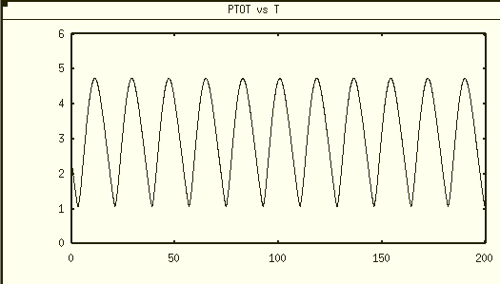

max Ptot ≈ 4.74, min Ptot ≈ 1.09, the average level of Ptot ≈2.92

NNF 1M8 Calibration of Amax with Vmax=5 (originally Vmax=1, from Dr. Tyson’s email, he suggested us to use Vmax=5)

1. calibrate for consistent average AT level

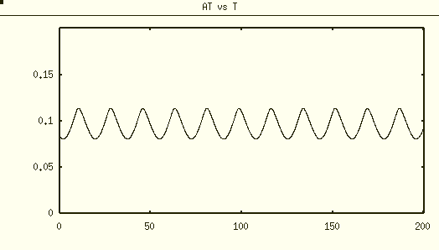

# NNF model

dAt/dt = delta * (FCATR*AMAX/(1+V) - At)

param Kd=0.1, delta=0.2, VMAX=5, AMAX = 0.3

param FCATR=1

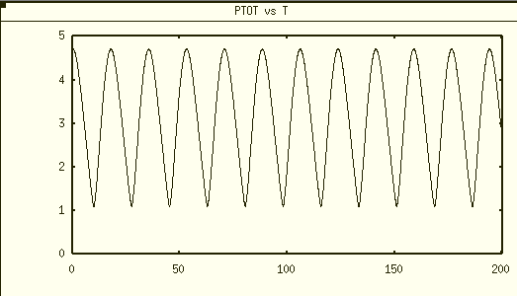

Ptot level is similar to SNF 1M8, with max≈4.71 and min≈1.11

# NNF AMAX=0.2

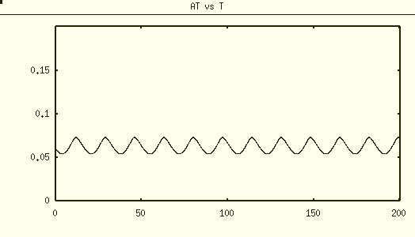

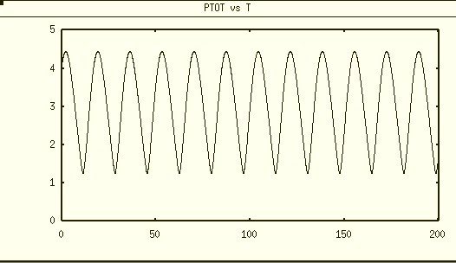

max≈4.44 and min≈1.25

PNF 1M8 calibration

# PNF model

dAt/dt = delta * (FCATR*AMAX*R/(1+R) - At)

param Kd=0.1, delta=0.2, RMAX=5, AMAX=0.15

param FCATR=1

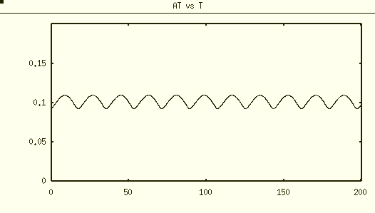

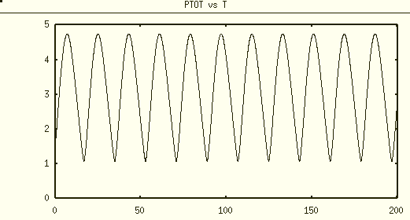

max≈ 4.74 min≈1.11

#PNF AMAX=0.2

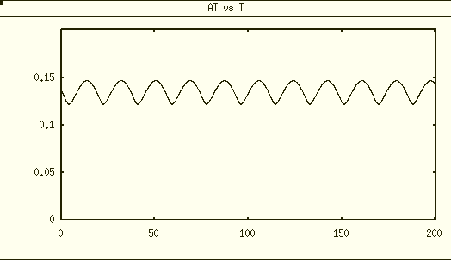

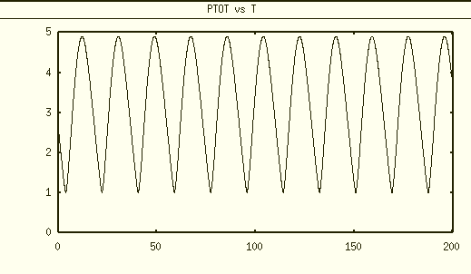

max≈ 4.90 min≈1.02

PNNF 1M8 calibration

# PNNF model

dAt/dt = delta * (FCATR*AMAX*(epsilon+R)/(1+R+V) - At)

param Kd=0.1, delta=0.2, RMAX=5, VMAX=5, epsilon=0.01,

param FCATR=1, AMAX=0.25

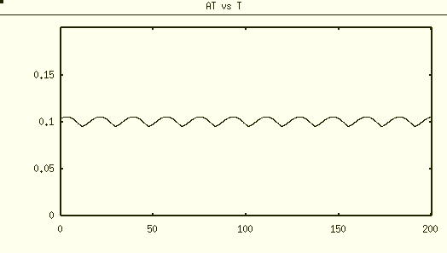

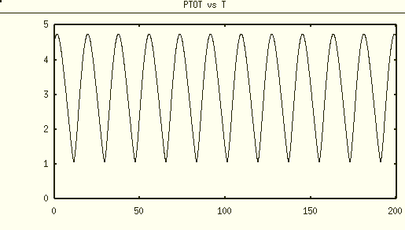

max≈ 4.74 min≈1.08

# PNNF AMAX=0.3

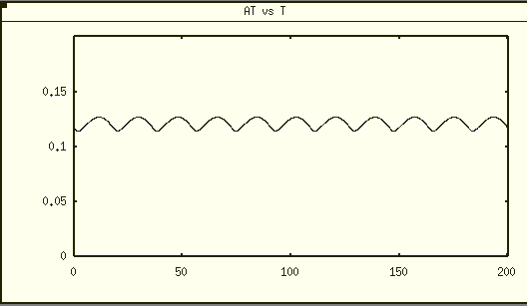

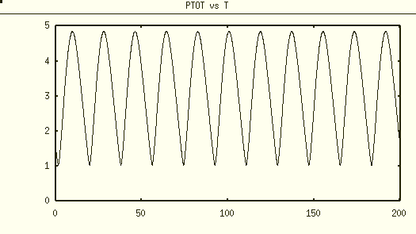

max≈ 4.85 min≈1.04